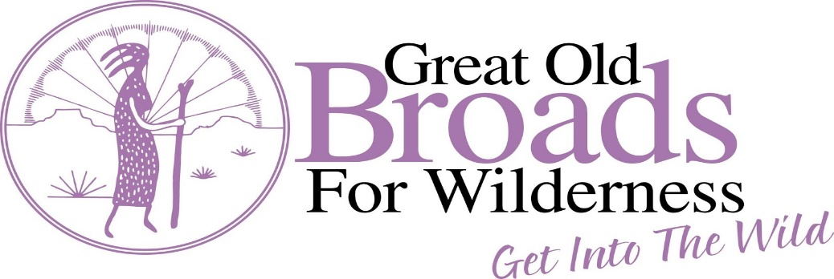
Aldo’s Silver City Broadband Newsletter Winter 2022 Vol 5 Issue 1

- OUR MISSION: GREAT OLD BROADS FOR WILDERNESS IS A NATIONAL GRASSROOTS ORGANIZATION, LED BY WOMEN, THAT ENGAGES AND INSPIRES ACTIVISM TO PRESERVE AND PROTECT WILDERNESS AND WILD LANDS. Conceived by older women who love wilderness, Broads gives voice to the millions of Americans who want to protect their public lands as Wilderness for this and future generations. We bring knowledge, commitment, and humor to the wilderness preservation movement. And, we’re educating communities about the critical connection between healthy public lands and climate change mitigation.
- OUR VISION: Wild public lands are treasured for their intrinsic values and protected for current and future generations.
- VALUES STATEMENT: Wilderness and public lands are for everyone; they are the heritage of all and a gift to future generations. Wild places, once destroyed, may be gone forever.
_______________________________________________________________________________________

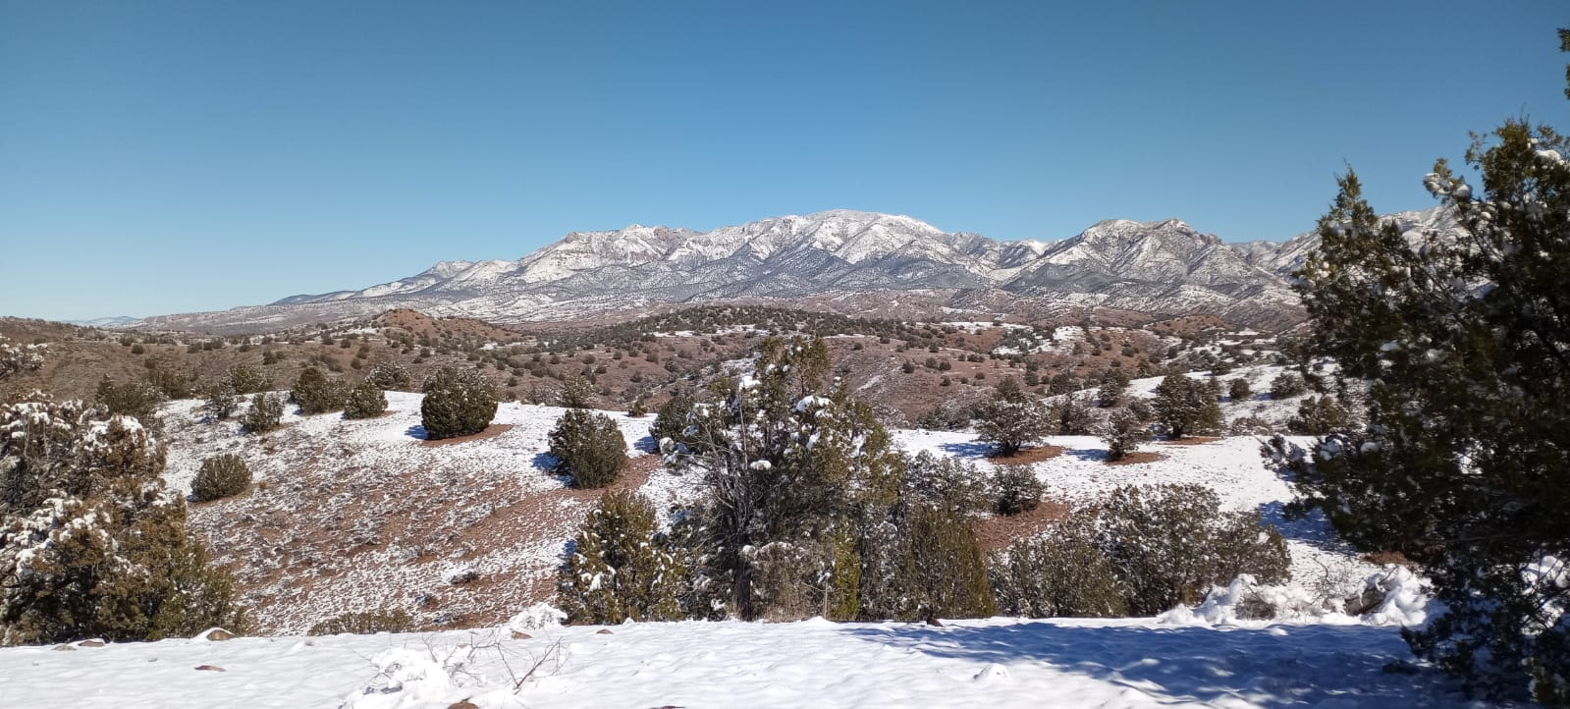

What’s up with Aldo’s Silver City Broadband?

Snow is gently falling as this newsletter is being composed, reminiscent of the snow that covered the landscape on January 1st. What a heartening way to usher in the new year! Here are some things that Aldo’s Broadband has been busy with and what we are looking forward to this year:

New Year, New Things to Share - We printed custom postcards for advocacy depicting several of our members hiking our public lands. If you would like a “handful” of these to send comments on public lands issues we are advocating for, please contact us at aldosgob@gmail.com. We also now have Aldo’s Broadband brochures that outline what we do. If you would like several to share with an acquaintance, let us know.

We plan to offer monthly Aldo’s Broadband hikes. For those of you interested in hiking, be on the lookout for emails with more details from our hiking committee. Our plan is to offer hikes on the second Wednesday of every month, meeting at Wolf Grounds Coffeehouse. The first one is scheduled for February 9 at 9 am but starting times will get earlier when the weather heats up. All hikers will need to be vaccinated and boosted, wear masks except when on the trail, and will need to sign a written waiver that will be good for the year.

Stewardship - Building on our grazing monitoring collaboration with the Gila National Forest, our monitoring team accomplished more than 900 hours of related monitoring actions while hiking riparian canyons and streams during 2021. One of the new (and delightful) landscapes we monitored last summer included the San Francisco River and tributaries near the NM / AZ border. Our efforts continue while bundling up warmly, given some streams have more water this winter thanks to impressive 2021 monsoons. Our monitoring focuses on streams that have been fenced to exclude cattle in order to protect riparian habitat – extremely important for biodiversity - and encompassed by The Center for Biological Diversity lawsuit which included habitat for streamside threatened and endangered species. The lawsuit was settled in August 2021. Our monitoring strategy remains relevant to that agreement, as we continue our volunteering efforts while reporting cattle impact, when found. (We made it into the Broadsides Fall 2021 newsletter - see that feature article, page 4, for more info!)

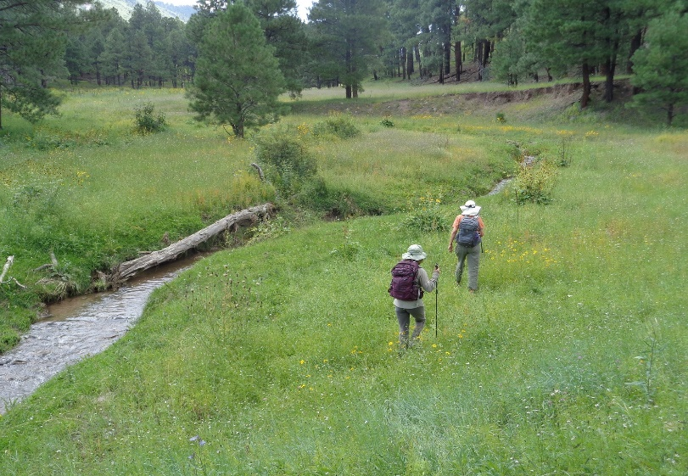
Embarking on a monitoring hike near the NM / AZ border, monsoons 2021

Advocacy – We just sent comments on the Mexican gray wolf 10(j) management rule to the U.S. Fish and Wildlife Service. We kicked off that effort with our December Zoom session as Michael Robinson oriented us regarding the management rule and ways the update could be improved. We signed on to the GOBW comment letter drafted by AZ- Sonoran Broadband Co-leader Roz Switzer.
2. We are following actions relevant to the Border Wall regarding impacts to wildlife and restoration of key damaged areas. We sent letters to our U.S. Senators and Congressional Representative. We sponsored a short video focusing on these border wall issues, compiled by Kate Scott (Madrean Archipelago Wildlife Center, and GOBW activist) and colleagues which was shown during the 2021 Gila Earth Day online event, coordinated by Gila Resources Information Project.
3. We wrote comments supporting NM House Bill 200 to prohibit further spending on the Gila River diversion and in support of replacing the New Mexico CAP Entity with the Water Trust Board. (Passed, and this important bill effectively killed plans to divert the Gila River into reservoirs.)
4. One of our dedicated members is helping us monitor the status of the NM Green Amendment proposal (HJR 2 Environmental Rights). We joined others in signing on to a letter to the NM Governor to encourage support of passage of the NM Green Amendment.

That’s just some highlights from our advocacy actions. Watch for our advocacy- oriented emails and thanks for letting your voice be heard! if you want to become more involved and are interested in wildlife / habitat connectivity, oil and gas extraction issues on public lands, planning for our gatherings / events, or public lands advocacy, contact one of our co-leaders - Joanie Connors or Marcia Stout at aldosgob@gmail.com. We would love to hear your ideas or have your help with tracking these issues, and advocacy!

Last but not least, stewardship, advocacy and fun rolled into one, GOBW style - After a year’s hiatus, last Sept. we were able to gather safely outdoors for our anticipated 7th annual retreat while camping along the Gila River. Some of us hiked, engaged with a service project at Gila Cliff Dwellings NM, and gathered for a talk on climate change and resilience by Carol Fugagli (Upper Gila Watershed Alliance). Not to mention soaking in the hot springs, gathering around the campfire, and enjoying a swimming hole framed by hoodoo- eroded towering cliffs. Here’s looking forward to our next retreat!

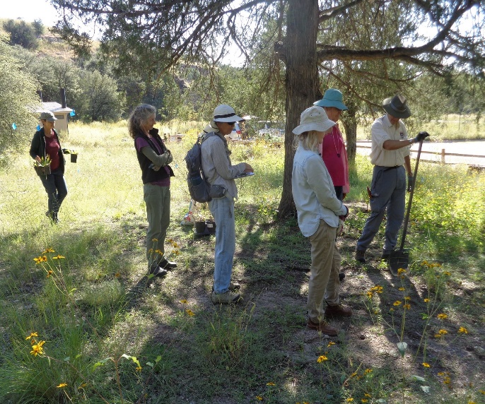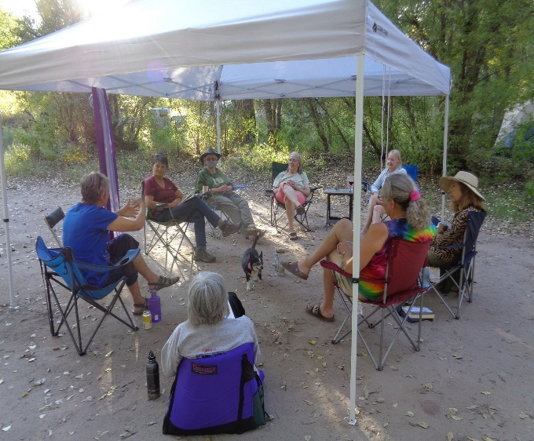
Preparing to plant native plants during retreat service project Gathering to share stories at sunset during 2021 retreat
_______________________________________________________________________________________

Head’s Up – GOBW is offering Wilderness Advocacy Leadership Training (WALTS) April 25 – 29, 2022 in Santa Fe. (No cost, except travel. Travel scholarships available.) WALTS involves leadership training sessions that are hands-on, experiential, educational, and fun. If you are interested in co-leading or leading Aldo’s Broadband while enjoying the camaraderie this generates, contact Marcia or Joanie at aldosgob@gmail.com, or Lisa at Lisa@greatoldbroads.org

************************************************************************************************************************
Broads To-Do’s:
- Like our Facebook page https://www.facebook.com/aldosbroadbandGOB/!
- Join the Broads! www.greatoldbroads.org
- Check out what national Great Old Broads for Wilderness is doing (and find membership applications) at www.greatoldbroads.org. There you will learn about priorities (Keeping public lands in public hands and preserving National public lands; Making public lands part of the solution to climate change; Keeping wild lands wild), Broadwalks and Broadworks which are open to members and non-members alike.
- Join us when we come together in support of a project or let us know if there is something you think we might look into.
