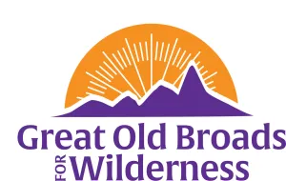
Cascade Volcanoes Membership Meeting Agenda 10/23/24
6:30 pm Kennedy School
5736 NE 33rd Ave Portland

Welcome Everyone! Bondi

“DEFEND THE DIRTY DEVIL” Jenny Holmes, SUWA

I. ADVOCACY:

· A. LSRD—Letter to Cantwell with Nimiipuu Ione Jones Laurie
Postcards
· . B. Dabbler Sale meeting November 21 Castle Rock Micky
C. DRAX UPDATES Micky
D. DNR Public Meetings 10/28; 10/29; 10/30 Laurie
E. Columbia River NEXT Proposal Laurie
G. Trust Land Transfer program sign on letter Wash Wild
H. Spirit Lake meeting October 30 at 6:30 pm Laurie
I. NW Forest Amendment Darlene

II. STEWARDSHIP
- Solitude Monitoring Laurie
- LCEP Plantings at Salmon Creek 11/2 Laurie
- WTA half day women Bondi

III. EDUCATION
- Washington Trails Conference: Laurie
- DNR Outdoor Access and Responsible Recreation Strategic Plan
- Forest Service E-Bikes
-Forest Service Workforce

- Wilderness and Beyond Conference highlights:
-Micky
-Bondi
-Laurie

- Book Groups:
  - “Emerald Mile” 2pm November 6 Laurie
  - “An Immense World” online October 25 4pm

IV FUN:
- Fort Vancouver hike Rosanne/Ann
- Campout 2025 Updates Bondi
Cascade Volcanoes Award Laurie

