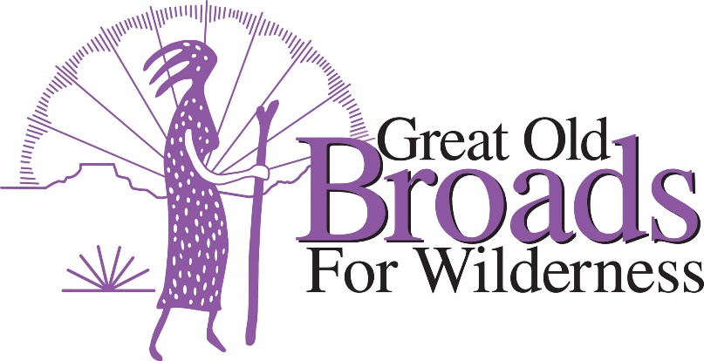
Cascade Volcanoes Chapter Meeting Agenda
March 15, 2022
5:30 – 8:15
5:30 – 6:30 Setup and Eat All
6:30 Welcome Everyone Laurie (All)
6:40 Presentation:
Michele Pinkham, Community Engagement and Development Manager,
NARA NW, Inc. “A siiméeys’ Perspective”

ADVOCACY: (7:15 - 7:45)
Source to Sea Event Micky
Earth Day Event Laurie
Pumice Plain/Green River Mining Susan
Elliott State Forest Felice
Oregon Forest Issues Felice

STEWARDSHIP: (7:45 – 8:00)
Lower Columbia Estuary Plantings Barb
Invasive Species Council Wash Laurie
Cascade Forest Conservancy Laurie
Trail Ambassador Program TKO Kathleen
EDUCATION (8:00 – 8:05)

Broads Movie Night/Justice & Equity Barb

FUN (8:05 – 8:15)
Campout Micky/Laurie
Hikes/snowshoe Barb
Fundraiser with Oregon Bike Laurie
Online Auction Micky
Bad Ass Broad Award Laurie



