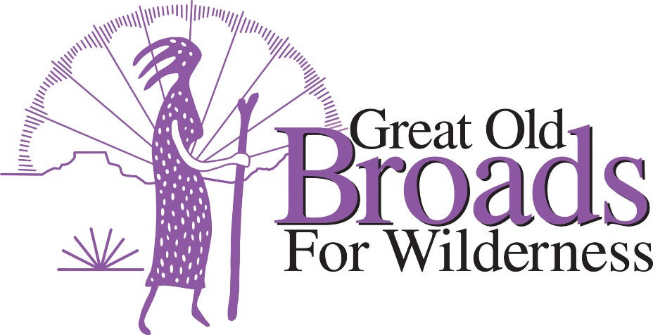
Clark County Advocacy Meeting Agenda
6:30 April 25, 2022
11102 NE 196th St Battle Ground, Wa

6:30 Introductions and Welcome! Laurie
6:45 “Mineral Withdrawal on Green River”, (CFC) Sean Roome
7:15 Fossil Fuel Moratorium Heidi
City of Vancouver Climate Action Plan
8:00 Pumice Plain updates Susan
Silver Star Visioning Plan, Washington Native Plant Society
Bird-friendly guidelines for Vancouver
8:15 Federal 30 X 30 plan for leaving federal lands not logged Laurie
Opposing Timber Harvests on Legacy Forests on private lands (CRF)
Washington State Preservation of Public Lands for Carbon Storage

