Inland Port Brief

Prepared for Weber County Municipalities

In 2023, the Weber County Commission passed a resolution support creation of a 900-acre Utah Inland Port Project Area. On January 2, 2024, the Weber County commission voted to expand the size of the project tenfold to almost 9,000 acres. The project area sits in Weber County near the west end of 12th Street.

Important dates:
- The Weber County Commission is holding a public listening event on Thursday, May 16 from 6-8 PM at the Weber County Commission chambers. They will accept public comment of two minutes per person.
- The Inland Port Authority is planning to vote on the Weber Inland Port at their next scheduled board meeting at the Capitol on May 20 at 1 PM.

Background:
The Utah Inland Port Authority (UIPA) is a quasi-governmental entity created by the state of Utah in 2018. The Utah Inland Port Authority Board is made up of three representatives chosen by the Utah legislature and two by the Governor. They have all decision-making authority over the expenditure of UIPA’s revenue, which comes from the legislature and tax dollars collected in communities with Utah Inland Port Authority Project Areas.

11-58-202. Authority powers and duties

The authority has exclusive jurisdiction, responsibility, and power to coordinate the efforts of all applicable state and local government entities, property owners and other private parties, and other stakeholders to: develop and implement a business plan for the authority jurisdictional land, to include an environmental sustainability component, developed in conjunction with the Utah Department of Environmental Quality, incorporating policies and best practices to meet or exceed applicable federal and state standards, including: emissions monitoring and reporting; and strategies that use the best available technology to mitigate environmental impacts from development and uses on the authority jurisdictional land; plan and facilitate the development of inland port uses on authority jurisdictional land and on land in other authority project areas; manage any inland port located on land owned or leased by the authority; and establish a foreign trade zone, as provided under federal law, covering some or all of the authority jurisdictional land or land in other authority project areas.

It is important for Weber County and local municipalities to understand that once a UIPA project area is created, it is managed by UIPA.

All decision-making authority over how local tax dollars dedicated to UIPA are spent are made by the UIPA board, regardless of differences with local governments. Each time the board of the Utah Inland Port Authority creates a project area, UIPA takes control of the tax revenue from the area for a certain number of years. UIPA gives local government 25% of the proceeds back, but local officials question whether that is sufficient to cover the costs of providing services such as road, sewer, safety, etc.

Currently, the project area land in Weber County is privately held. However, this is a project using taxpayer funds and is thus subject to transparency, notice, and accountability.

In the West Weber General Plan adopted in 2022, the area west of 8300 West is primarily zoned for industrial use. The plan does not address the costs or consequences of turning farmland into a paved-over warehouse district or the truck service that it will attract.

The plan notes wetlands throughout the area, concerns about water availability and quality, and other infrastructure needs. The plan also states that there was very little public involvement in its creation.
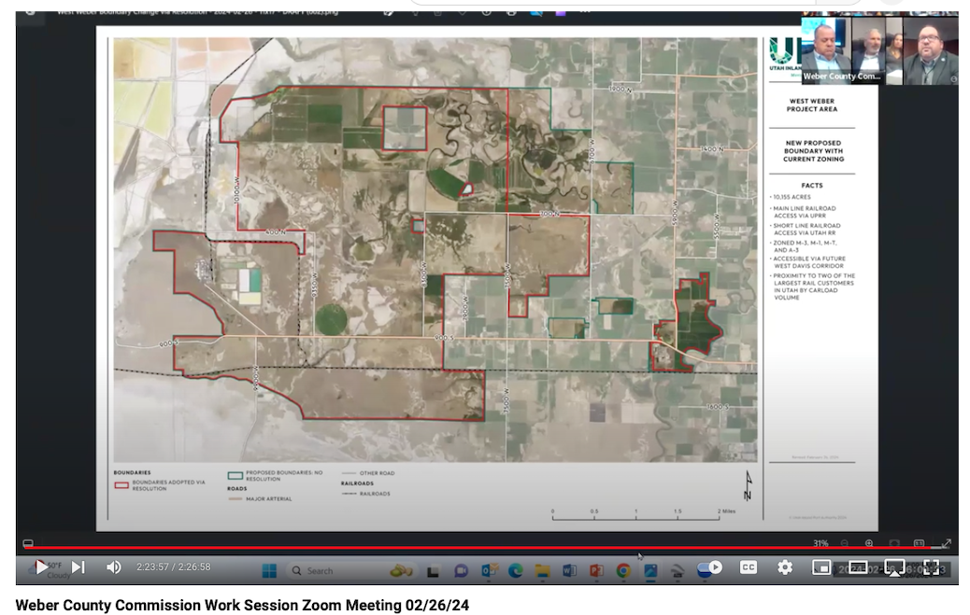

A contentious process: Port Authority vs. Salt Lake City/County

Creation of UIPA by the legislature in 2018 was extremely contentious. Citizens and elected officials expressed concerns about the purpose, benefit, consequences, taxpayer costs of publicly subsidized development, and the fast-track approvals.

Six years later, critics have observed that the promised benefits have not materialized. For example, in Salt Lake County, UIPA is currently paying $120,000 per month to lease empty land. Salt Lake City/County’s hands are tied.

When the legislature first created UIPA it was only for the purpose of creating an inland port in Salt Lake City. The majority of revenue is still in the hands of the UIPA Board to spend.
Community members in Weber County are only beginning to learn what the issues are, are expressing concern, and are asking that the UIPA Project Area be put on hold until the questions are answered.

Opposition expressed: Slow down for time to understand the issues.

There is a perception among many that this project is being rushed without proper time to understand local ramifications. A petition by Weber County Residents has already been delivered to the Weber County Commission. Another was delivered to the UIPA board with 1,639 names outside Weber County.

Questions and potential ramifications to vet:
- What are the costs such as road maintenance, policing, and other services?
- What are the economic benefits and where/how do funds flow?
- How is an Inland Port different than locally driven development, such as a county industrial park?
- What is the business plan for this project area? Has it been fully evaluated and vetted for veracity?
- Has an objective evaluation of other Inland Port areas been conducted?
  - How successful have other areas been?
  - What have been the economic benefits and costs?
  - How satisfied have local municipalities been with their working relationship with the Port Authority?
- Is this needed? Is it needed where it is being proposed? At this scale?
- What is the community sentiment? Do local municipalities fully understand the project?
- What are the environmental impacts including:
  - Destruction of biological wetlands, impact on highly sensitive wetlands that are directly adjacent in the Ogden Bay Waterfowl Management Area. Is the Port Authority’s wetlands plan adequate?
  - Bright lighting – there is currently no plan to address light pollution or the impact of this lighting on wildlife in the adjacent wetlands
  - Noise and air pollution
  - What are the mitigation plans, and are they sufficient?
- What are the legal risks to moving forward too hastily?
- What might be the political costs of pushing an unpopular project forward?
- What is the opportunity cost to the community for conceding such a large tract of land for this purpose?
- Have alternatives been considered?
- What promises has Weber County we been given? How ironclad are they?

For further reading/attachments/links to have ready (or embed)
- Proposed plan?
- Utah Inland Port Authority Wetlands plan, November 6, 2023
- “Great Salt Lake Wetlands: Harms from Utah Inland Port Development”
- Weber County Master Plan

Requests:
- Call your colleagues in other municipalities and/or our legislative leadership and ask them to weigh in with the Commissioners.
- Consider writing an official letter from your municipality expressing concern over the project.
- Ask the Weber County Commission to rescind approval until the questions have been properly answered and a proper public process has taken place.

Photos taken by Rhonda Lauritzen late April, 2024 showing sensitive areas of OBWMA closed to foot traffic, spring lakes within the project area, and birds including pheasants within the project area.

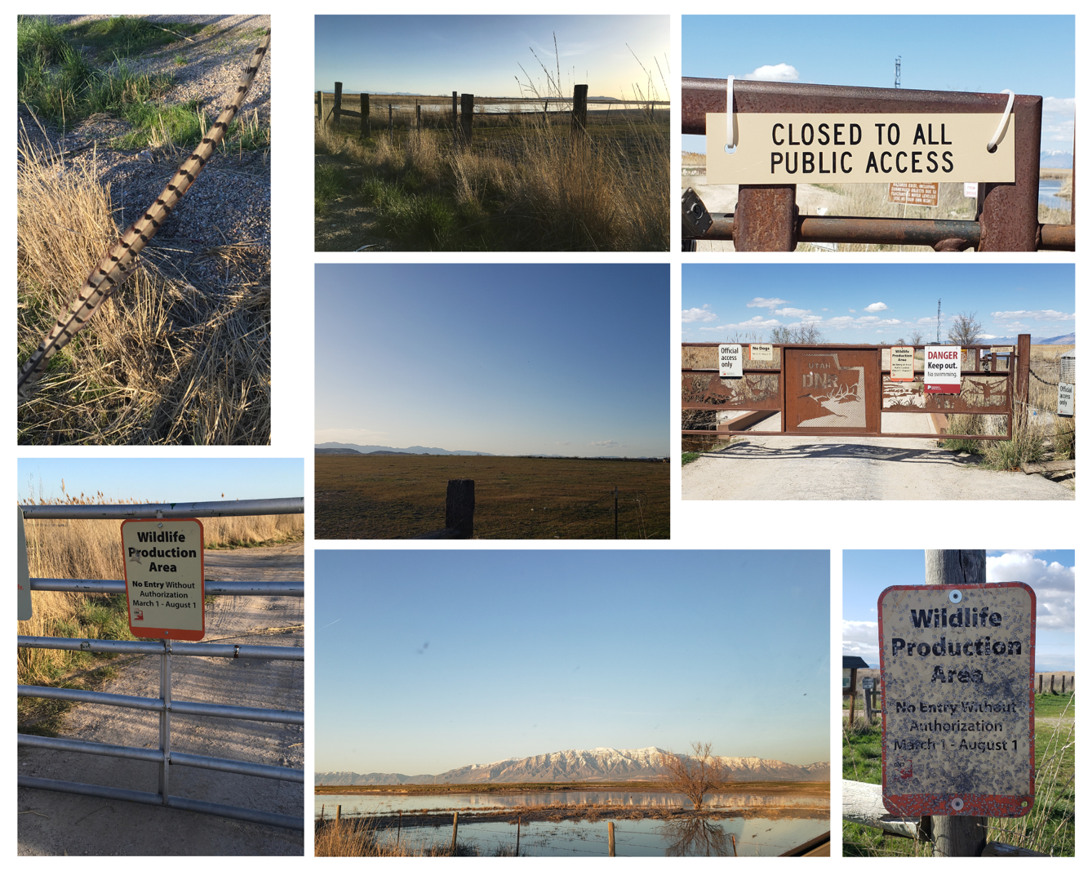

Rhonda Lauritzen’s thoughts:
The Weber County Republican Platform states, “Government functions best when it is closest and most accountable to the people…”
It adds that, “America’s economy and the prosperity of individual citizens are best served by a system built on free enterprise, economic freedom, private property rights and the rule of law. This system is best sustained by policies that promote general economic freedom and eliminate governmental preferences for special interests…”

There is a perception among many that this is being driven by private developers who are getting a sweetheart deal from the state through subsidized development and low-interest loans. Some speculate that the rushed timeline is to cash in while conditions are ripe, and to push approvals before the community has a chance to learn about it and object.

This would permanently concede a massive area to industrial development and preclude housing or other long-term opportunities there. The Port Authority states a desire to benefit the environment by reducing truck traffic. However, the impact of this Inland Port project would be to bring large trucks to an area where there is little traffic now. Light pollution has not been addressed.

The state is spending millions to manage the adjacent wetlands. These areas are closed to all foot traffic for six months of the year due to sensitive nesting. On the previous page are pictures I took this month showing the entrances to the bird refuge (OBWMA) closed to foot traffic for six months of the year. The 12th street entrance is adjacent the proposed port. I spotted a half dozen pheasants in the fields of the proposed project area, and spring lakes teeming with life.

